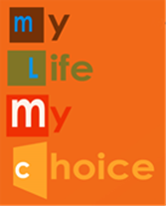
My Life My Choice

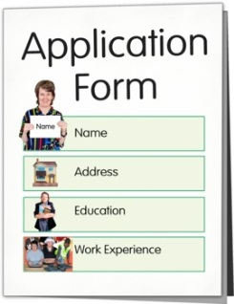
Application form for the job of Quality Checker

Introduction

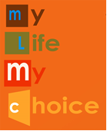 | My Life My Choice has some new jobs.
 | The jobs are called Quality Checkers.
 | The Quality Checkers will be paid to check services for people with learning disabilities.
 | The Quality Checkers will be supported to do their job.
 | A My Life My Choice Quality Checker has to be someone with a learning disability.
 | A Quality Checker needs to know about or have experience of using services like day services, respite, and supported living.
 | A Quality Checker needs to be confident about speaking up.
 | To find out everything about the job you need to read the Job Description and the Skills Needed sheet.
If you want to know more about being a Quality Checker contact Jess Roberts.

TEL: 01865 204214

jess@mylifemychoice.org.uk

About you

Section 1 – Contact details
 | Name:
 | Address:
Telephone
Number:
 | Email Address:
How would you like to be contacted:

Do you have permission to work in this country? |  |  | Yes  No
My Life My Choice tries to be an equal opportunities employer.

Section 2 – Interest in the job and skills needed
Answer the two questions in the boxes
1. Why would you like this job?

2. Why would you be good at this job? Think about the skills and experience you have that would make you good at this job.

Section 4 – Qualifications, certificates and awards
What qualifications, certificates and awards do you have?

Name of the qualification, certificate or award | Date you got the qualification, certificate or award

Section 5 – Training courses
What training courses have you done?

Name of training course | When did you do the training course?

Section 6 – Paid work or voluntary work
What jobs have you had? This could be jobs that are paid or voluntary

Where did you work? | What was the job? | When did you work there?  From To

Section 7 - Referees
Please give us the contact details of 2 people we can contact to ask for more information about you. The people should be somebody like a previous employer or tutor. These people will need to be able to tell us why you would be good at the Quality Checker job.

Reference 1 |  | Reference 2
Name |  | Name
Address |  | Address
Telephone Number |  | Telephone Number
Email Address |  | Email Address
How do you know this person? |  | How do you know this person?

Section 8 – Criminal Convictions
Criminal Convictions

Do you have any criminal convictions? | Yes No
If you answered yes, what are they?

Section 9 - Support
Support to help you in your work

Do you have a disability? | Yes No
If you answered yes, tell us what support you need:

Section 10 – Declaration
Declaration

Please sign below to say that what you have written is true.

Signed: |  | Date:

Section 11 – Contact Details

Please return your completed form to:

Jess Roberts
My Life My Choice
The Jam Factory
27 Park End Street
Oxford, OX1 1HU

jess@mylifemychoice.org.uk

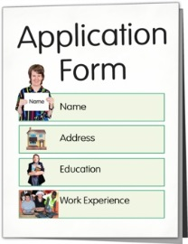
We must receive your application form by:
7
12 noon

Registered charity number 1073247

