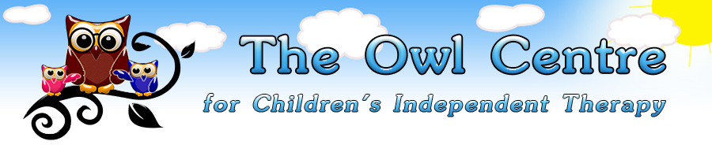 Two Day Beginners’ Course
Makaton Signing Training
For Parents / Carers/ School Staff
This Beginners’ Workshop provides a practical introduction to the Makaton Language Programme.
Sessions include: discussing commonly asked questions, hints and tips for effective signing and symbol use, and how to start using Makaton in everyday situations at school or at home.
You will learn the signs and symbols from Stages 1-4 (and Additional) of the Core Vocabulary. All signs and symbols learned on the course are included in your manual which can be purchased through us and received on the day. You will also receive a certificate of attendance.
Trainer: Michelle Staniforth, Specialist Speech and Language Therapist, The Owl Centre.
Venue: Oxford Association for the Blind, Bradbury Lodge, Gordon Woodward Way, Oxford OX1 4XL
Dates: 1st and 2nd December 2016
Time: 9.30am to 3.30pm
Cost: £150 (includes £30 for set of
Makaton Manuals, necessary if not owned)
Deadline: Bookings by 10th November to allow
time to order manuals
The Owl Centre in Oxfordshire also offers Speech and Language Therapy, Occupational Therapy, Dyslexia Assessments and Support, Classroom advice for Autism by our SEN teacher, Dramatherapy, Music Therapy, and Dance & Movement Therapy.
www.theowltherapycentre.co.uk

