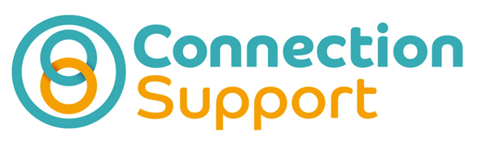
Connect-Up Oxfordshire – Direct Payment Networking Group
Are you a Direct Payment user receiving a Personal Budget from either Social Services or your local NHS?
Do you support someone else to manage and use a Direct Payment?
Are you a parent or someone with parental responsibility for managing a direct payment on behalf of a child?
If you have answered yes to any of the questions above you may be interested in attending Connect-Up Oxfordshire, a local networking group for people using Direct Payments.

What Connect-Up Offers -
- The opportunity for people to meet other Direct Payment users and improve knowledge, understanding and confidence with using Direct Payments to buy care and support services in Oxfordshire
- Information and advice in all aspects of using a Direct Payment and Employing Personal Assistants.
- Training to become a Direct Payment Mentor and share experience and knowledge to help others become more confident using Direct Payments
- Close working with both Oxfordshire Country Council and Oxford Health to ensure Connect-Up members can become a voice for Direct Payment users in Oxfordshire and help guide local Direct Payment policy and practice.

If you’re interested in attending Connect-Up please contact -
Ann Cummings - Administrator
Tel: 01865 410307 Email – AnnCummings@connectionsupport.org.uk
Address: 213 Barns Road, Cowley, Oxford, OX4 3UT

